**Bi-directional RNN**

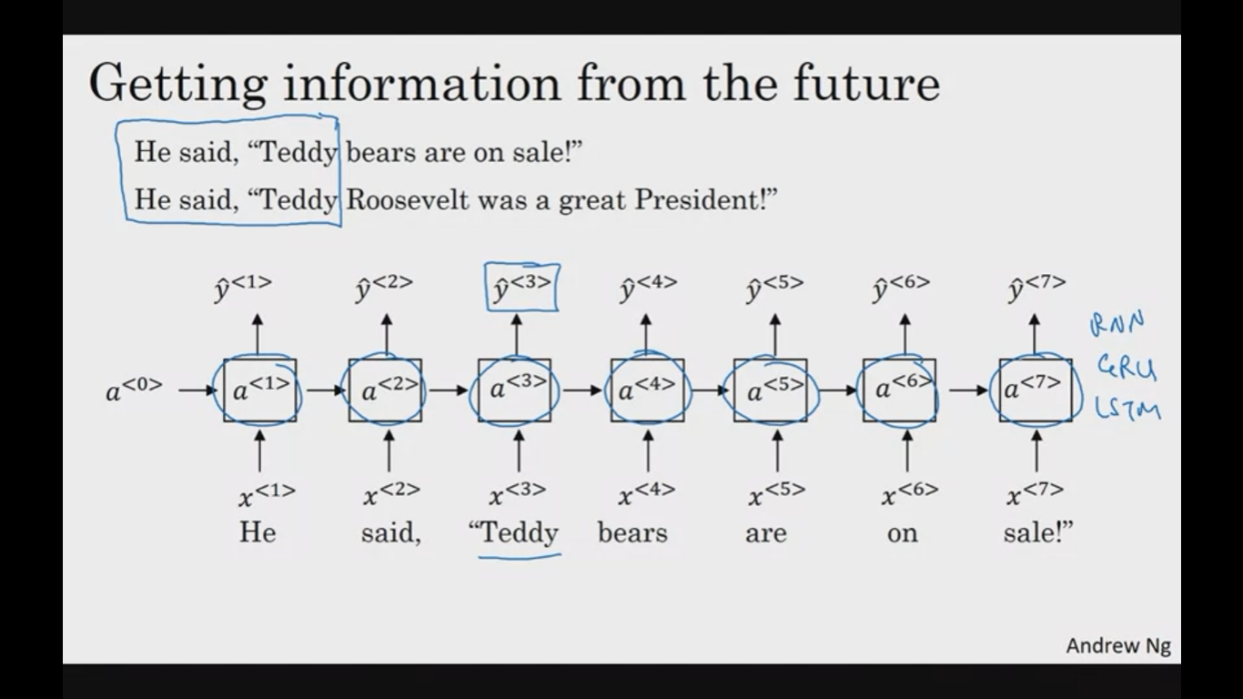

The presented model cannot differentiate between two sentence until 4th word encounters this is resolved by using B-RNN.

Architecture:

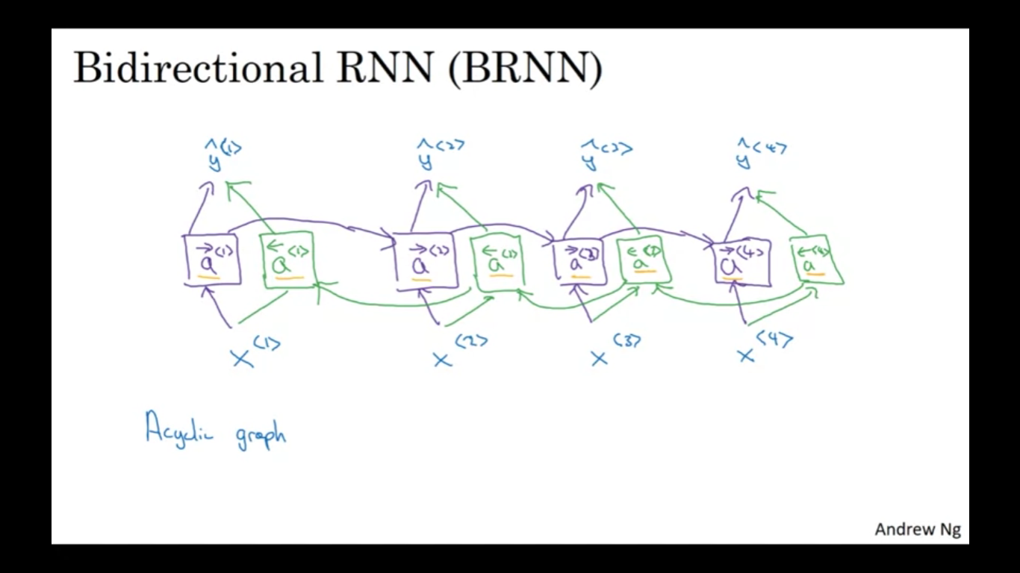

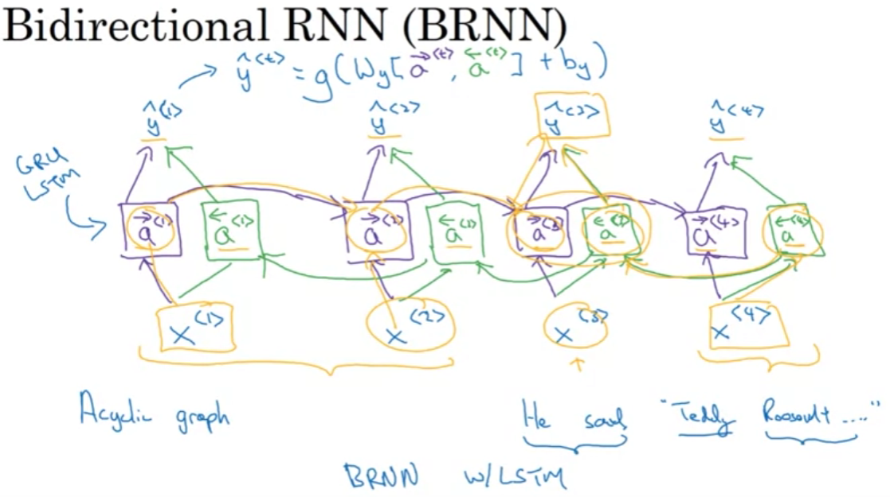

Disadvantages:

Need data upfront